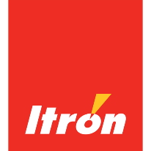
Based in Liberty Lake, Wash., Itron Inc., a world-leading technology and services company dedicated to the resourceful use of energy and water, has been a long time Bloomsday sponsor in various capacities. Today, Itron sponsors the race’s more than 50,000 race numbers, the Photoboxx photo station and a Corporate Cup team. In past years, Itron had a tradition of organizing and managing a volunteer water-aid station. Itron employee Rich Layton shared this comment: “Volunteering with my co-workers and my sons at the Itron Bloomsday water-aid station was a great way to share in the community and teach my children the value of giving back and having fun at the same time. It was a great feeling.”

Itron teams have been participating in Bloomsday Corporate Cup since 1985. Corporate Cup is part of the culture at Itron. Teams are memorialized with photos in the "Bloomsday Hallway" leading to the fitness center in the company’s Liberty Lake headquarters. Each year is represented with a team picture from 1985 to 2015. It's a Hall of Fame of sorts.
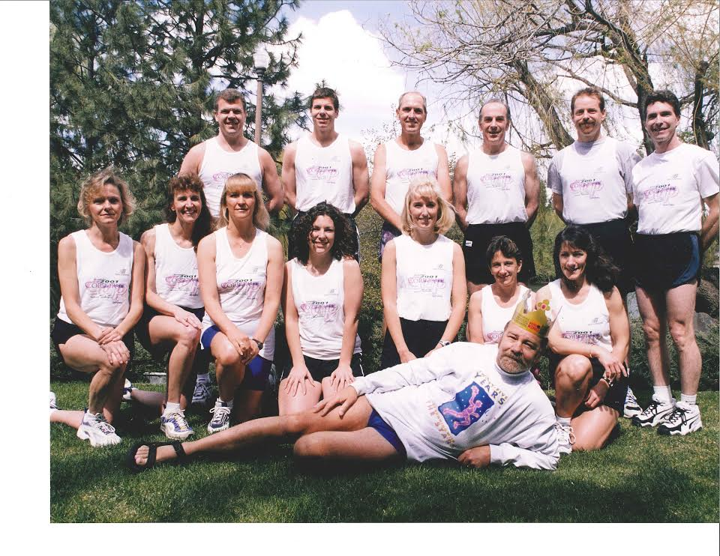

One of the long-time team members is Val Kuntz who also acted as team captain for many years. When the registration process moved online, she would rise at midnight to register teams via a slow, and not so friendly, dial-up connection just to ensure the Itron teams got a spot due to the limited number of Corporate Cup teams available. Today, the interest in Bloomsday is so high that a lottery is conducted to randomly select employees for Itron Corporate Cup teams.
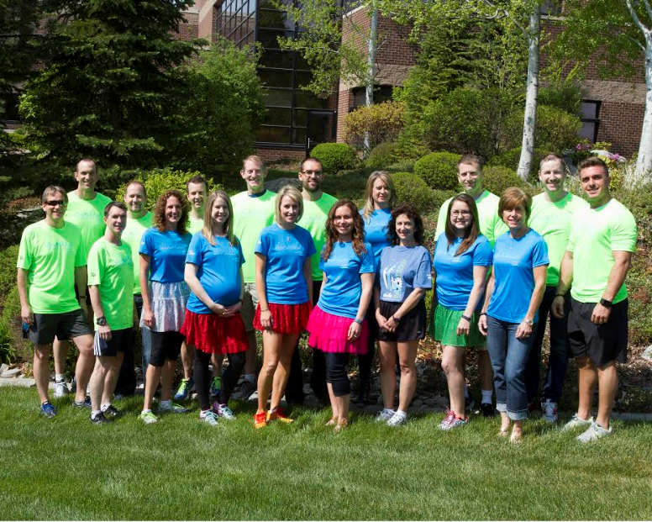

Robert Fitzner, who is a graphic designer in the Corporate Marketing Department, has been designing Itron-branded Bloomsday t-shirts for the last 10 years, which are available for Itron employees to purchase to commemorate their Bloomsday experience. He and his 17-year-old daughter Makenna have participated together in every Bloomsday since she was born. It's a family tradition he hopes will continue after she leaves for college next year.

Lunch and evening run opportunities are the norm at Itron year round, but especially during Bloomsday time. As part of its Itron Fit program to encourage health and wellness, employees representing a wide range of pace and distance options gather for runs and social outlets. Itron employees are often working heads down at computer stations and individual cubicles; Bloomsday is an opportunity for employees to make new connections and break free of their work stations. A few weeks prior to the race, employees are invited to join in a preview run covering the entire Bloomsday course as a group, ending with a gathering at a local establishment.
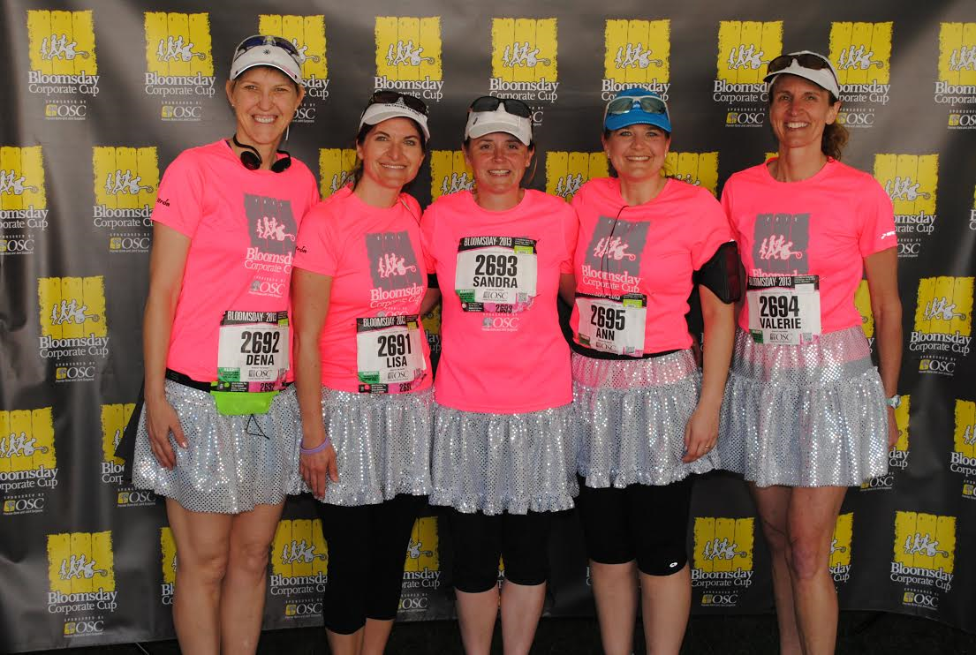

Callie Bendickson, Itron’s community relations manager, said, "Bloomsday brings the Itron family together in a unique way. The buzz and excitement of Bloomsday creates a unique atmosphere that can't be replicated. Everyone wants to be a part of Bloomsday because it is a signature and special event in our community!"

